AMERICAN INTERNATIONAL UNIVERSITY BANGLADESH (AIUB)
FACULTY OF SCIENCE & TECHNOLOGY


Course Title
INTRODUCTION TO DATABASE (CSC2108)

Semester:
Section: [ ]

TITLE
Name of your Project system

Supervised By
Name of the Faculty

Submitted By: Group no: xx
Name | ID

TABLE OF CONTENTS

TOPICS |  | Page no.
Title Page |  | 1
Table of Content |  | 2
1. | Introduction | 3
2. | Case Study | 4
3. | ER Diagram | 5
4. | Normalization | 6-14
5. | Finalization | 15
6. | Table Creation | 16-22
7. | Data Insertion | 23-29
8. | Query Test | 30-34
9. | DB connection | 35

Introduction
Demonstrate / explain the topic of your project. The tools that you are going to use in it. Your vision or goal after the accomplishment of the project. Your contribution in the tech sector through this project. Which sort of people will be benefitted from this kind of project and whom are your targeted users.

Case Study / Scenario
## demonstrate the scenario or the system entities and their relationships. Mention the properties or attributes for each entity along side cardinality. The unique identifier or primary keys of each entity should also be mentioned.

ER Diagram

## Provide the jpg/png file of your ER diagram after the drafts being checked by your course teacher
## you can use any of the diagraming tools like Dia Diagram, visio, lucidchart, draw.io etc

Normalization
## Show the process of normalization up to 3NF for all the relations in the ER diagram

Finalization
## Eliminate the duplicate tables if found any in normalization after 3NF. Show the final tables of the system with their name.

Table Creation (DDL Operations)
StudentID1: Name: | StudentID3: Name:
StudentID2: Name: | StudentID4: Name:
CO4: Creating DML, DDL using Oracle and connection with ODBC/JDBC for existing JAVA application
PO-e-2: Use modern engineering and IT tools for prediction and modeling of complex computer science and engineering problem |  | Marks
## Provide the screenshots of your commands for created tables in oracle.
## Provide the description which shows the structure of the table.

Inserted Values in the tables
## Give the screenshot of all the created tables in Oracle. All the tables should be attached one by one.

Query Test in DB
## There will be one simple query. One with Group/ Aggregate function, 2 single row Subquery, 2 Multiple Row subquery, 4 different type of joining.
- simple query
- Query with a single row function
- Query with a Multiple row function/ aggregate function
- 2 Single row subquery and 2 multiple row subquery
- 4 kinds of joining
1 simple view
1 complex view
## Provide query first, next the command for the query and at last the output:
In the end show a simple view and a Complex view:
Demo of a simple view is given below:
SIMPLE VIEW:
à create a view named as eview30 where the deptno 30 will be shown over the columns ename, empno and deptno
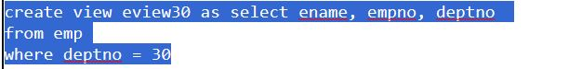
fIG: Simple view creation command
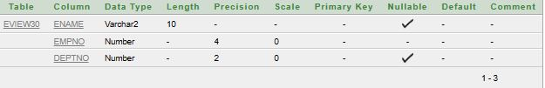
fig: Description of the simple view
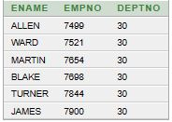
Fig: Result of the simple view as a whole table

Description of a Successful DB connection
## Its up to the presentation / explanation capabilities of the student. Each student has to show the DB connection process individually and put the description in this file one after another mentioning their name. Student can use either MySQL or Oracle.
what do we need?
1. Mysql java connector (jar file)
You can go to “mysql java connector maven” any version you like
2. You need to search (xampp apache mariadb perl php) install xampp server normally
3. Select the xampp icon control UI and then start both apache and mysql. Next go to mysql admin panel
4. now create a Database , inside of it create table and insert the values in the table
The table in mysql
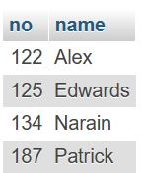
Now we need an IDE.
Before that, we need to understand the steps of DB connection
- Register Driver
- Connect the DB
- Create statement
- Execute the query () in the resultstmnt
- Connection close ()
5. Now write the DB connection code and add the jar file location in the libraries
The output will be
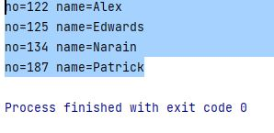

Conclusion
## Mention the future aspects of the work along with a short summary of the whole project activity.

